Application for a University Center/Institute at Florida State University

1. Cover Sheet

Name of the center:

Fiscal year center to be implemented:

Approvals:
Provide signature lines according to https://provost.fsu.edu/institutes-centers/guidelines/

Signature director, department chair or program director, dean (as appropriate), Provost, and University President when appropriate

2. Directory Information, Mission and Area(s) of Focus

- Provide the name, title, address, phone, fax number, e-mail address and qualifications of the proposed director. Also provide the website of the institute/center, if available.

- Indicate the Type of institute/center, based on the classification guidelines presented in the Chancellor's Memorandum.

University Center or State of Florida Center according to BOG rule

- Indicate with which academic discipline(s) will be most closely affiliated with the institute/center.

- Indicate whether this institute/center was created by the Legislature. If so, list the Statute Number or Chapter law.

- If institute/center is a part of another unit, please specify if it is any of the following and give details in regard to that choice.

The choices are Umbrella, Subunit, Host (with affiliate I/Cs at a different university), Affiliate, Joint.

- Provide a brief mission statement for the institute/center (75 words or less).

- Indicate how goals and objectives of the proposed institute/center relate to the institutional mission statement as contained in the Board of Governors' (BOG) Strategic Plan.

The major goals of the Center are:

These goals will relate to institutional mission statement of FSU in the BOG strategic plan by doing:

- Provide a rationale for this institute/center as a priority for development at FSU and/or in the State.

- Provide a description of activities (research, public service, and training) in which the institute/center will be involved. Indicate how the institute/center will allow faculty/staff/students to do what they could not solely in a departmental or divisional setting.

- Provide an overview of similar institutes/centers in the State and describe how this institute/center is different or the same.

- Identify key terms/phrases that indicate the major areas of focus for the institute/center.
These terms will be used as identifiers in a searchable database.

- Indicate what entity will be responsible for evaluating this institute/center and their contact information.

- Indicate how the establishment of the Institute/Center enhances the research and development activity currently ongoing.

- Indicate how the Institute/Center will encourage collaboration beyond what is currently in place (such as weekly seminars, journal clubs, etc.).

- Indicate the type and source of funding for the Institute/Center staffing once it starts generating its own research proposals.

- Indicate how SRAD is proposed to be distributed among the collaborating Colleges or Departments.

3. Staffing and Budget Information

- Provide estimated expenditures, number/type of positions, and rate for the first and fifth fiscal years. (Separate position and budget data should be submitted for each university when more than one university is affiliated with an institute/center.)

- Budget Total Expenditures requested in the following categories- SUS appropriated funds, C&G funds, Fees for Services, Private and Other

- Positions: Faculty Positions (FTE in Person years), and A&P and USPS (combined FTE in Person years) for the following categories - SUS appropriated funds, C&G funds, Fees for Services, Private and Other

- Provide departmental account number(s) for source of funds to support institute or center.

- Provide the projected number of graduate assistants to be assigned to the institute/center during its first year of operation.

• Provide the following information regarding projected space requirements (in square feet):

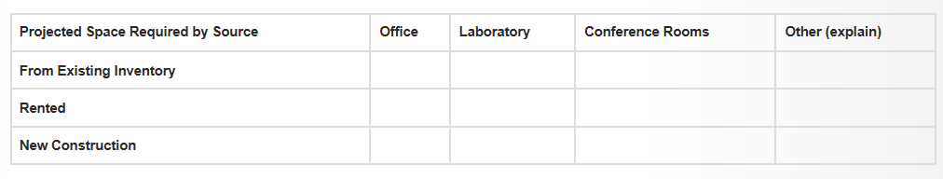

4. Organization

Describe the proposed administrative and organizational structure of the institute/center. Provide an organizational chart which delineates the functions of all faculty and staff. For proposals involving more than one institution, include such information for each participating institution as well.

5. Performance Measures

Propose a set of performance measures by which you would gauge the progress toward your goals and objectives for the next three years.

SAMPLE

GOALS | OBJECTIVES | STANDARD (targets)
 |  | 2019-20 | 2020-21 | 2021-22
1. Recognized as a national source of scholarship on democratic performance
 | 1a. Published Articles
 | 1b. National Conference Papers
2. Growth in funding sources
 | 2a. # of submitted proposals
 | 2b. # of funded proposals
 | 2c. Total awards
 | 2d. # of sources of funding
3. Source of training for graduate students
 | 3a. # of students supported on grants
 | 3b. # of students attending symposia
4. Foster collaboration among faculty
 | 4a. # of joint publications
 | 4b. # of joint proposals
5. Foster collaboration between faculty and graduate students
 | 5a. # of joint publications

6. Sunset Determination Model

Propose a process and the factors (i.e. performance, change in funding, change in personnel) by which the determination to deactivate this center/institute will occur. Include how the center/institute will be closed (i.e. management of personnel, equipment, facilities, accounts, etc.).

EXAMPLE: Annual performance evaluations will be made. Every three years, a review of these performance evaluations will be used to determine whether or not progress is being made to center/institute goals and that an expectation can be made that support will be available to continue productive activity. The Dean of the College of ***** will determine, in consultation with the Office of the Provost, whether or not there is feasibility to continue activity. If and when it is determined that a center/institute should be deactivated or discontinued, it is the responsibility of the Dean and the Director to manage the deactivation. These activities typically include the termination and/or reassignment of personnel, resource management and adjustments, and notifications regarding changes in activity.

